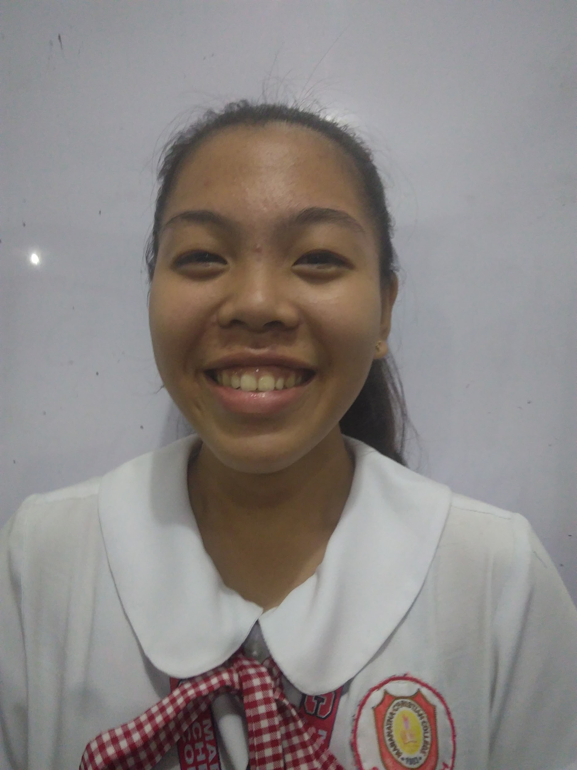

YOUR 1x1 PHOTO HERE

Keziah Marie E. Tornea
Prk.Kamunsil, Brgy.Bata Bacolod City
Mobile 09500806791
Email:kmetornea@maranatha.edu.ph

Objectives
Examining, analyzing, and preparing financial records and statements for an organization.often provide input and advice on financial matters including those systems used to track and record costs and expenses.

Summary
Certified Public Accountant

Educational Background

Accountancy and Bussiness Management
University of the Philippines
SY 2020-2024

Awards
Suma Cumlaude SY 2020-2024
Class Honor SY 2016-2018
Perfect Attendance SY 2017-2018
Best in Reading SY 2011-2014
Organizations
*Choir
University of the Philippines
*Philippine Red Cross
University of the Philippines

Skills
*preparing accounts and tax returns
*auditing financial information
*compiling and presenting reports, budgets, business plans, commentaries and financial statements

Work Experience
Bank of the Philippine Island
Capitol Subd, 17th Street corner, Lacson St ·Bacolod City
(034) 702 3087

Position Accountant
Duties
prepares or assists during preparation of financial statements.
Work Timeline August 2025

References
Available upon request

